Open new CCS project.

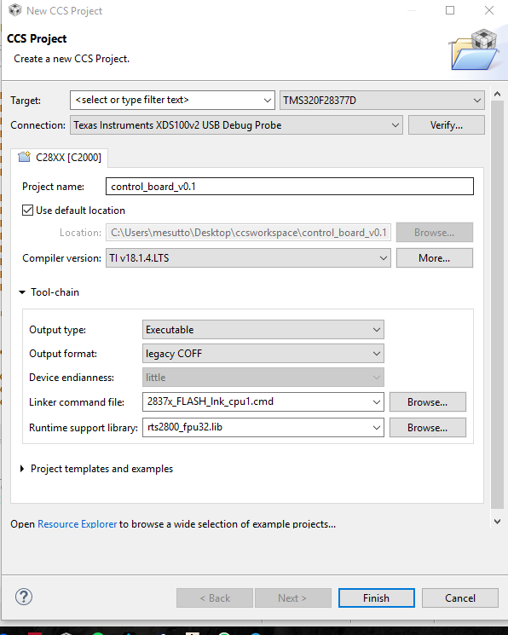

2837x_FLASH_lnk_cpu1_bist => Bu olacak !

When you need to print screen, use snipping tool !

Project sağ tıkla => Properties => Predefined Symbols

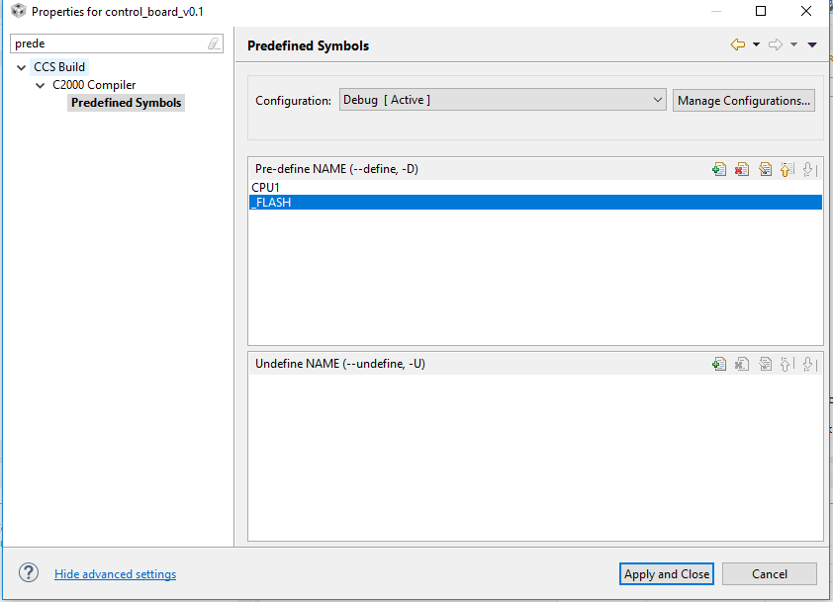

Project sağ tıkla => Properties => Include Options

C:\ti\controlSUITE\device_support\F2837xD\v100\F2837xD_common\include

C:\ti\controlSUITE\device_support\F2837xD\v100\F2837xD_common\source

C:\ti\controlSUITE\device_support\F2837xD\v100\F2837xD_headers\include

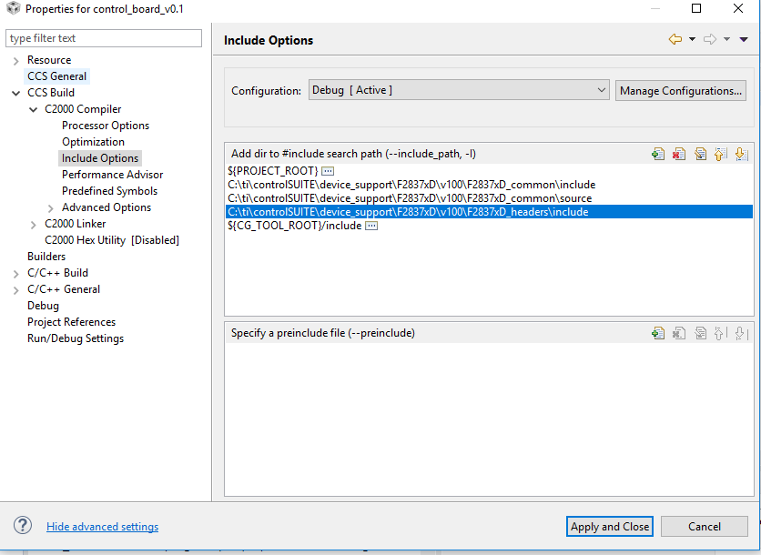

Projeye sağ tıkla => Add files

C:\ti\controlSUITE\device_support\F2837xD\v100\F2837xD_headers\cmd

F2837x_Headers_nonBIOS_cpu1.cmd

Do not link, directly copy it !

Projeye sağ tıkla => Add files

C:\ti\controlSUITE\device_support\F2837xD\v100\F2837xD_common\source

F2837xD_CodeStartBranch.asm

F2837xD_usDelay.asm

Do not link, directly copy it !

Projeye sağ tıkla => Add files

C:\ti\controlSUITE\device_support\F2837xD\v100\F2837xD_common\source

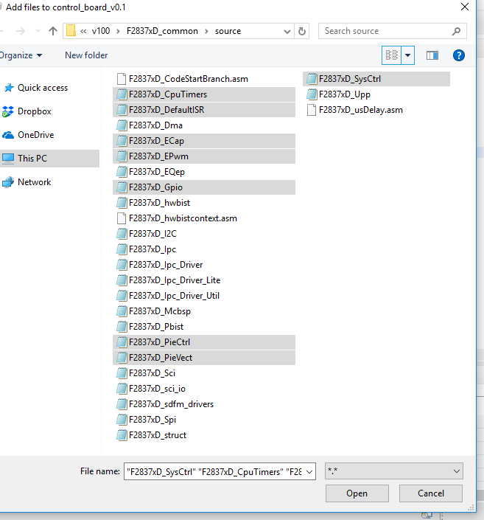

Projeye sağ tıkla => Add files

C:\ti\controlSUITE\device_support\F2837xD\v100\F2837xD_headers\source

F2837xD_GlobalVariableDefs

Bu önemli. Neden bilmiyoruz.

**#include** <F2837xD_Pie_defines.h>

When you hit debug button, make the following selection:

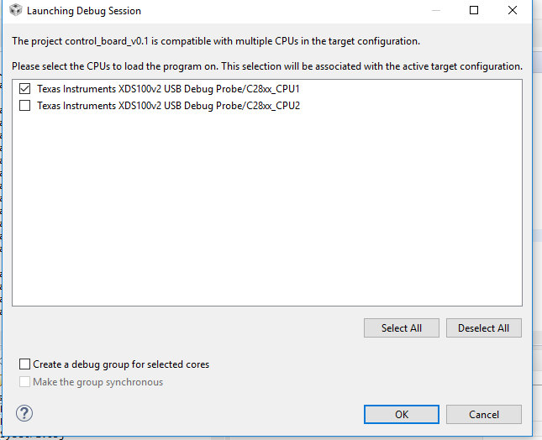

XDS100V3 yapmak lazım.

Clock sıkıntı. See below:

//InitSysPll(XTAL_OSC,IMULT_20,FMULT_1,PLLCLK_BY_2); //PLLSYSCLK = 10Mhz(OSCCLK) * 40 (IMULT) * 1 (FMULT) / 2 (PLLCLK_BY_2)

InitSysPll(INT_OSC1,IMULT_20,FMULT_1,PLLCLK_BY_2);